1. What is Terraform?

Terraform is an Open – Source infrastructure as code Software Tool Created By Hashicrop User define and Provide Data center infrastructure Using a declarative Configuration Language Known as Hashicrop Configuration Language Or optionally Json.

Terraform is a tool for Building, changing and versioning infrastructure Safely and efficiently.

There are two Platform

1. Linux Server
2. Windows

First we create the instance in Aws

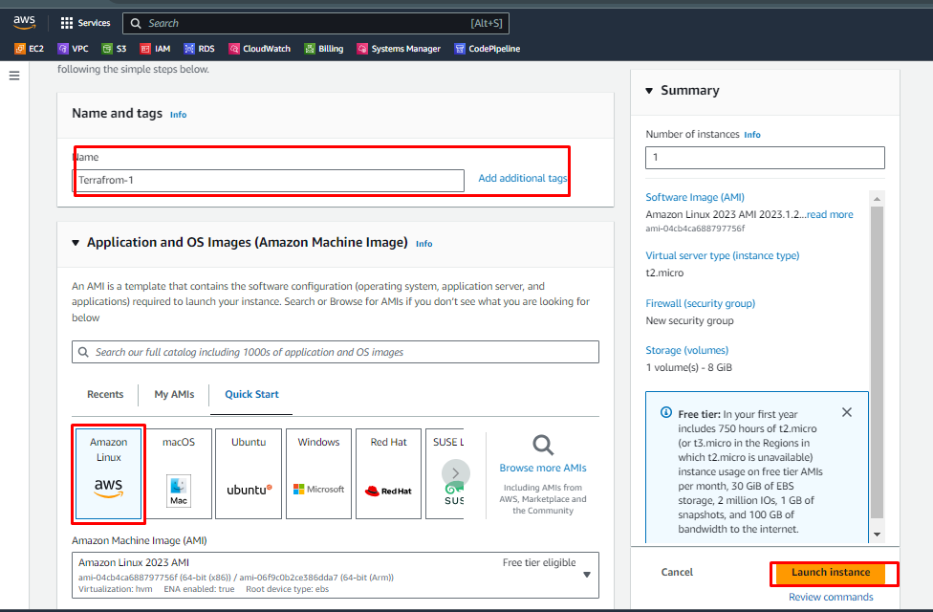

Now I connect the Server in a MobaXterm

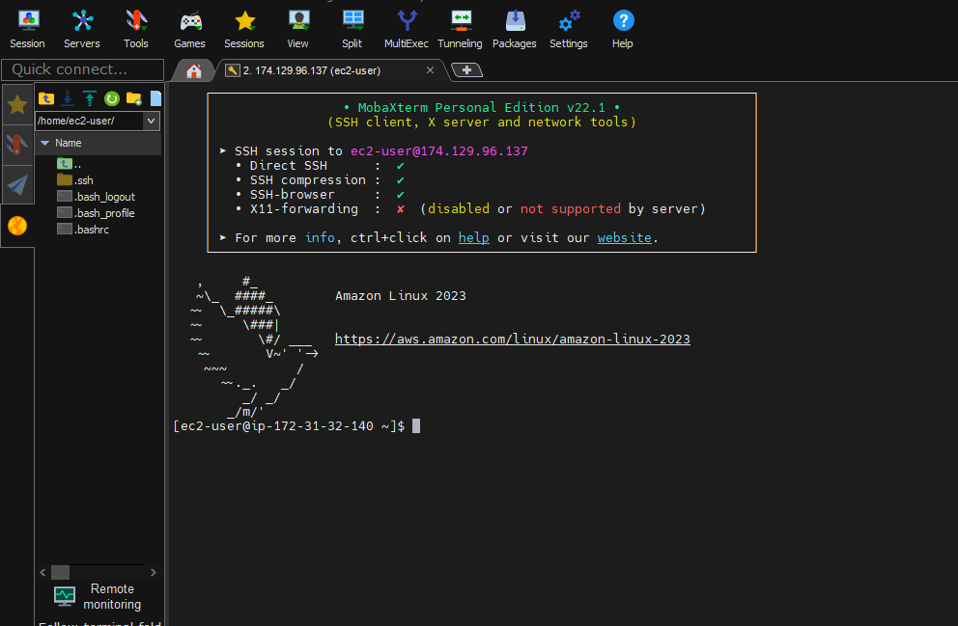

Now How to install the Terraform In a server and windwos

Goto official wed site of Hashicorp and click on install Terraform Then click on PACKAGE MANAGER FOR LINUX what Type of Server you select that.

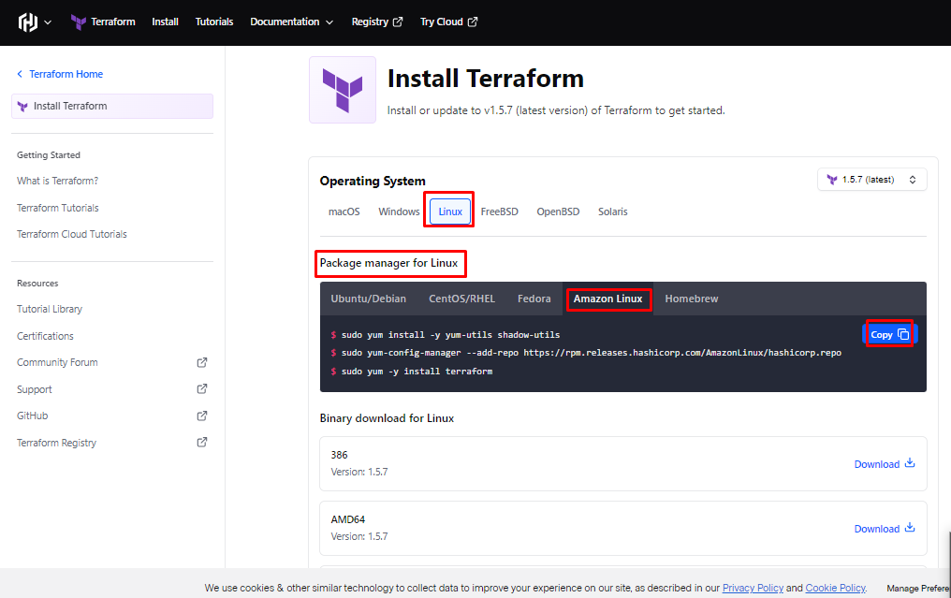

Now installing the Terraform in a linux Server

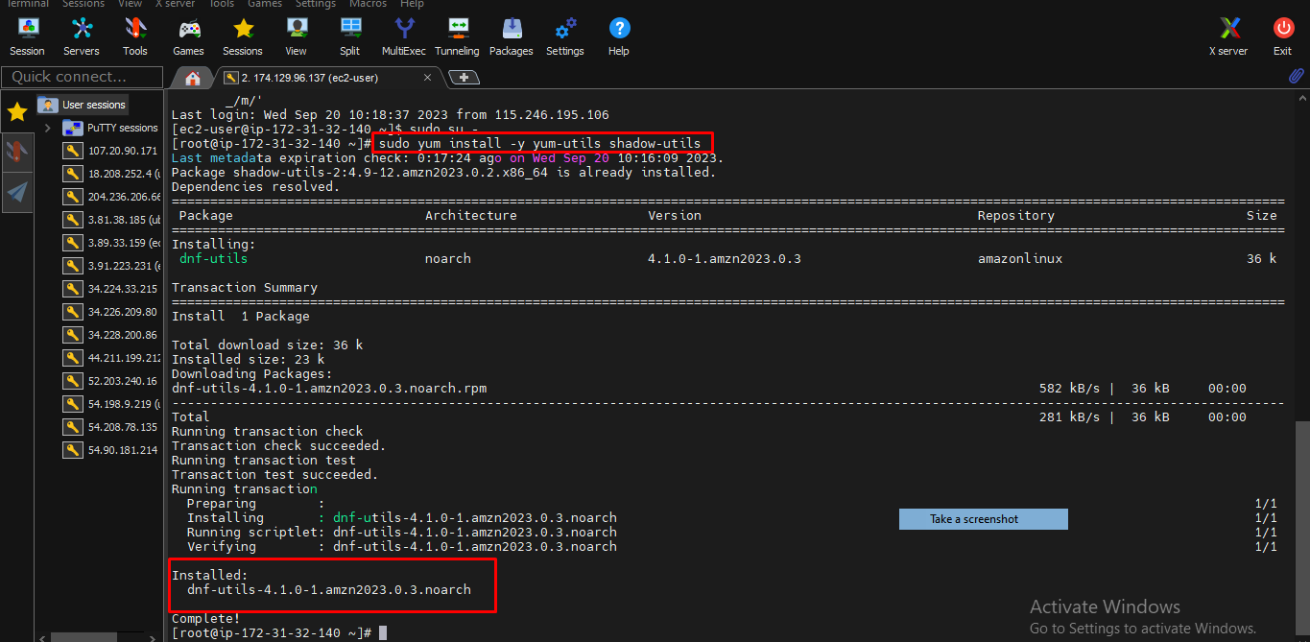

This Screenshot Create the hashicorp File

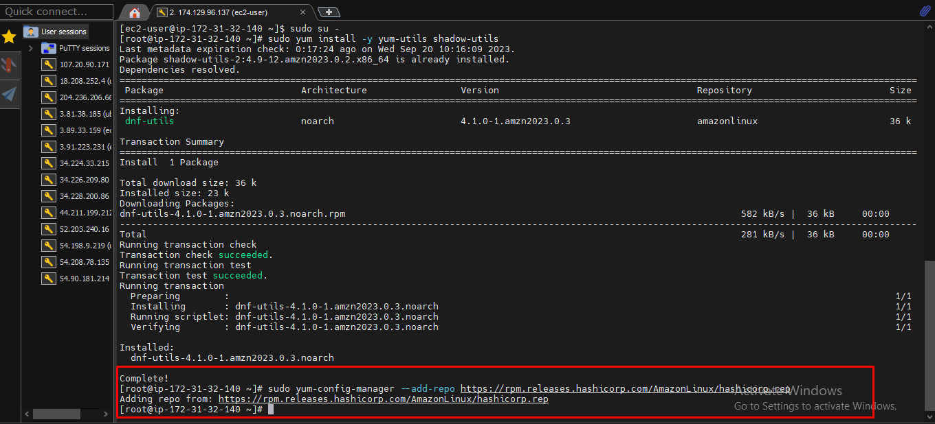

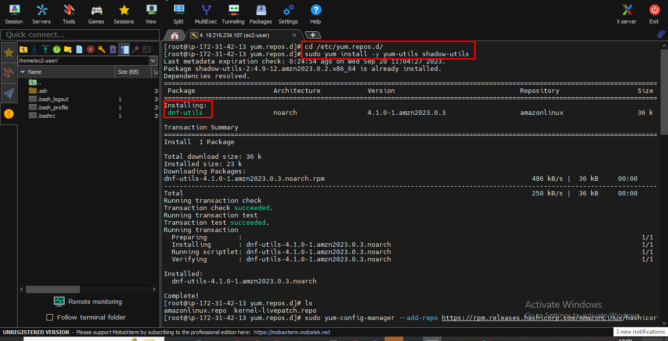

This is Package of this terraform

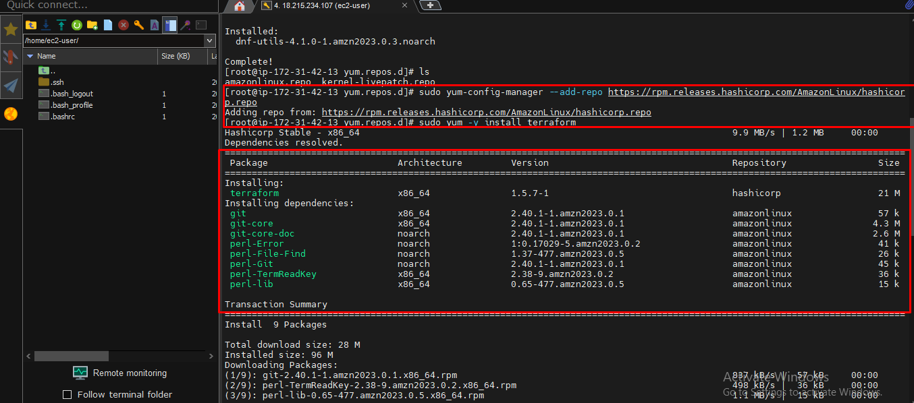

Terraform Update version

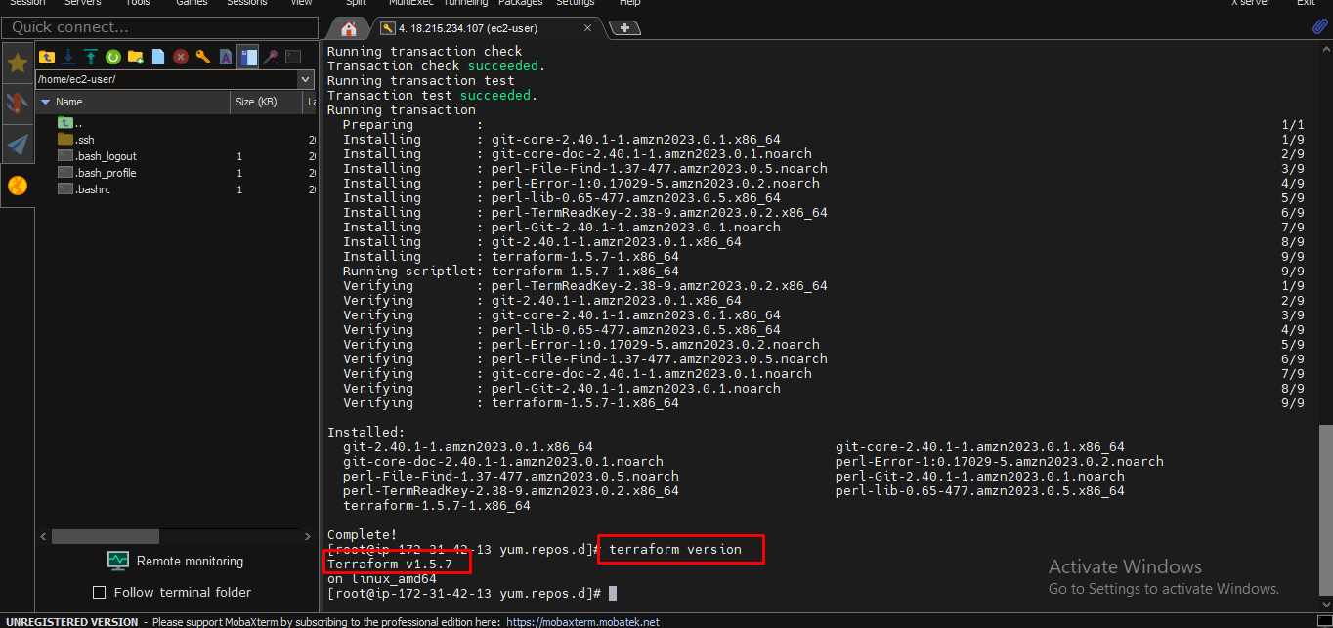

This Command show the Aws version AWS cli – command

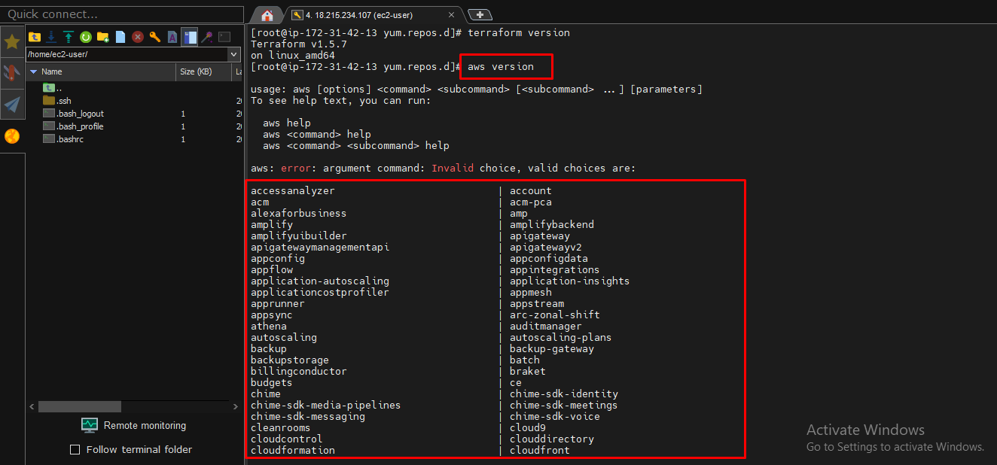

Next step give the AWS access key and secret access key

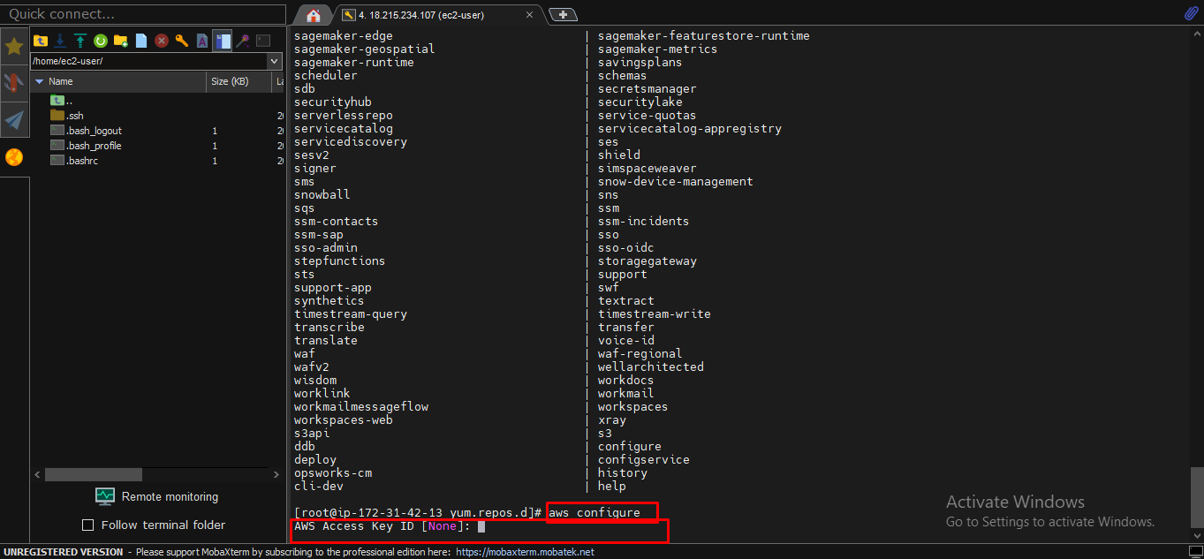

Secret key

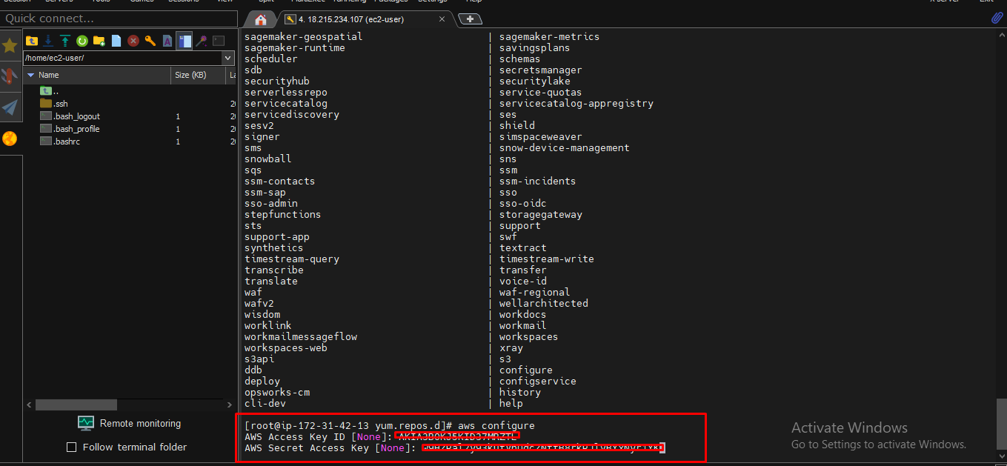

Configure link with terraform Command = Aws Sts get-caller-identity.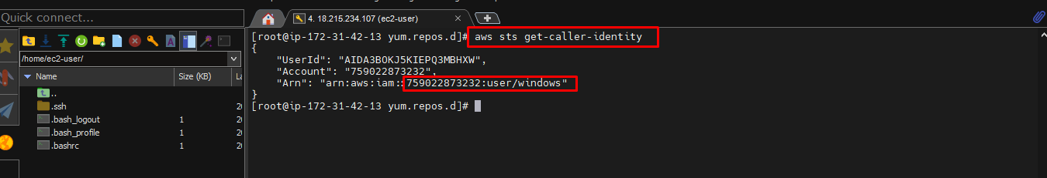

Goto instance And take the AMI ID (Amazon Machin Images) Just Take

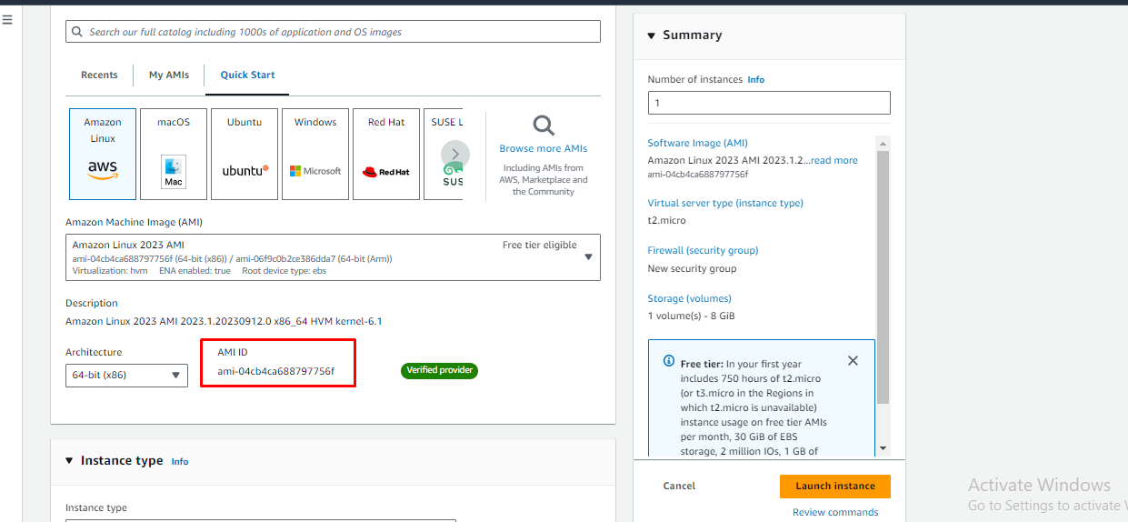

I Create the cd /opt/ create Mkdir the folder in this folder Vim Main.tf Terraform script in this file

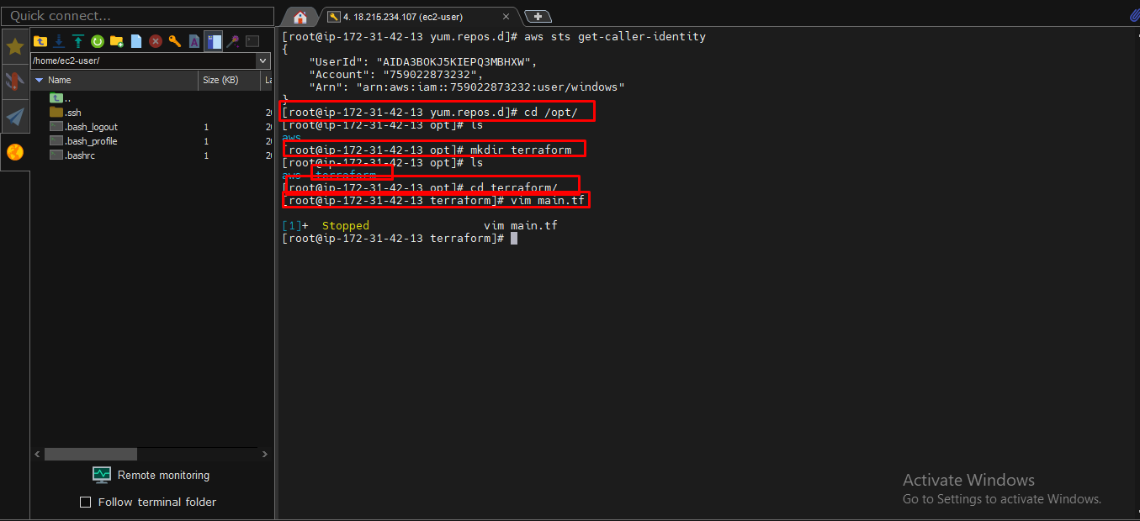

This is Terraform Format Script

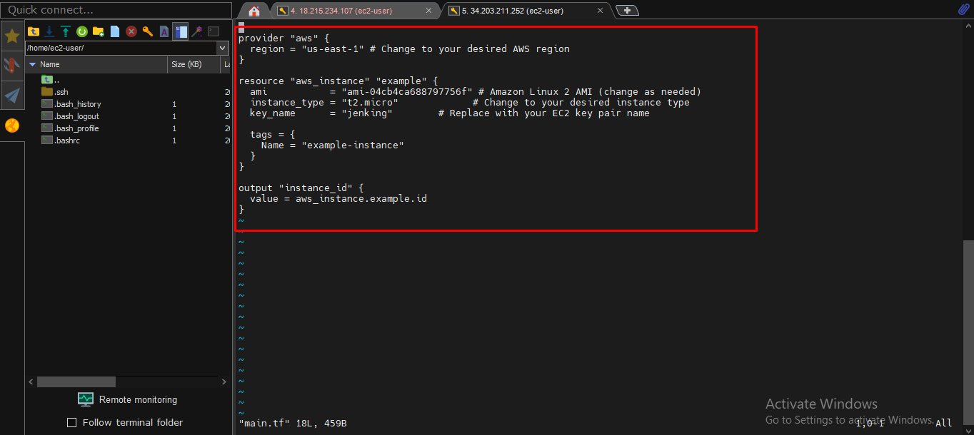

This Error show the First If any mistake in Terraform script Unlock Configuration block shows

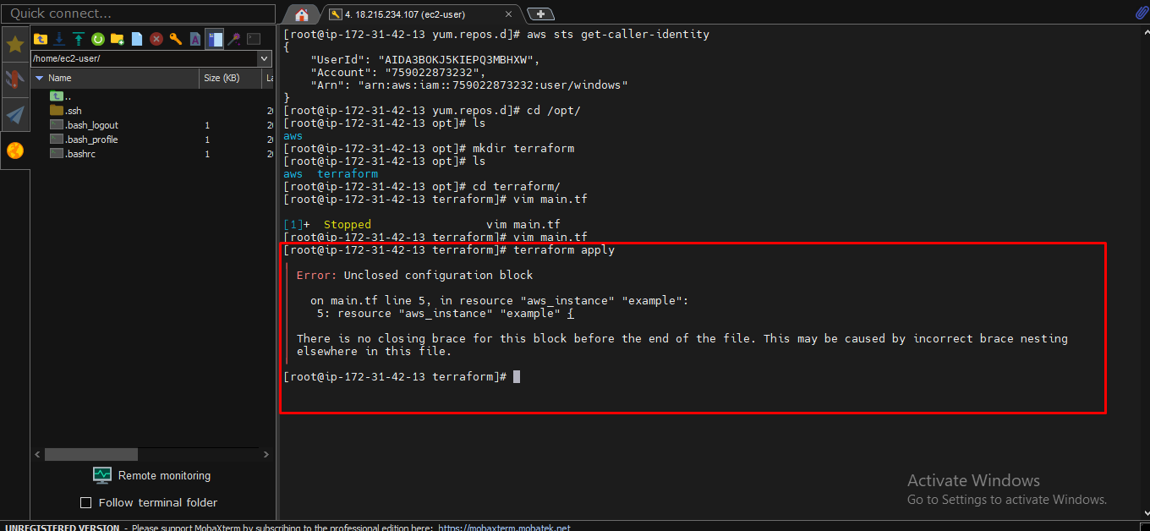

Terraform Inti means = this command all dependency Download for terraform Packages

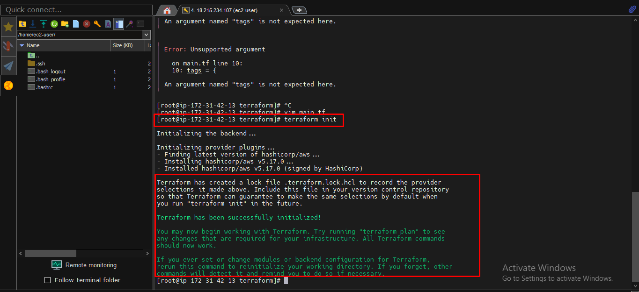

If instance will launch means Enter

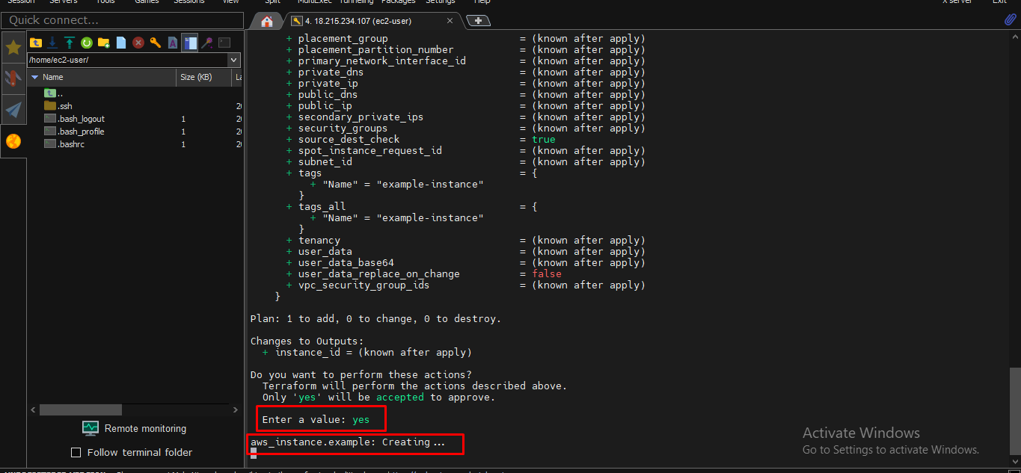

Instance will launched

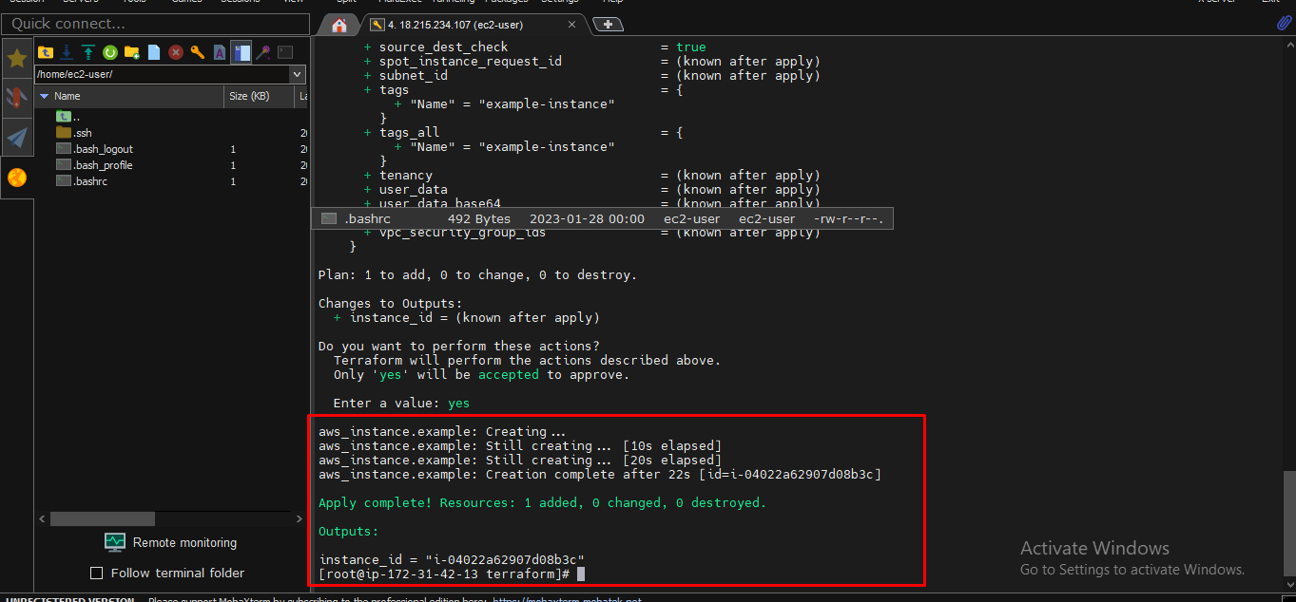

Completely launch instances

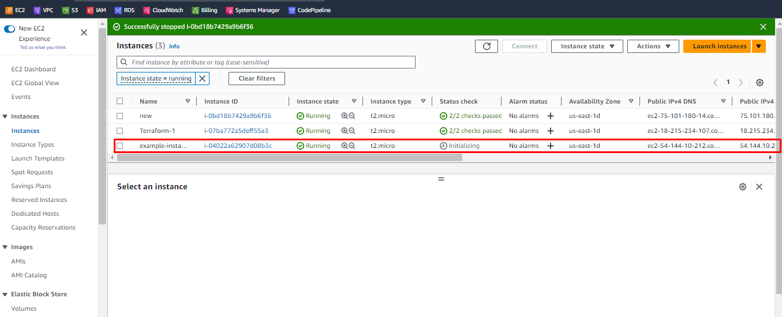

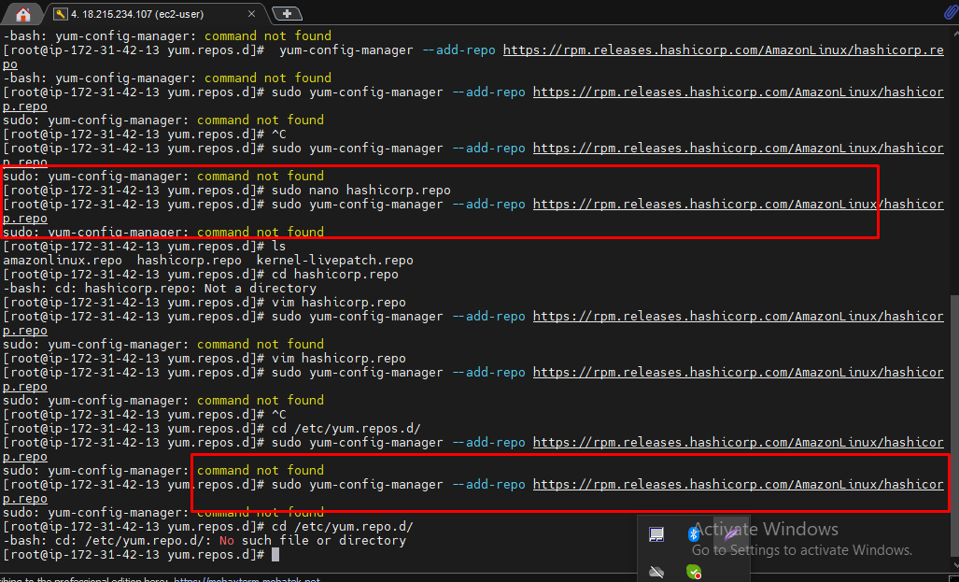

How to install in Windows

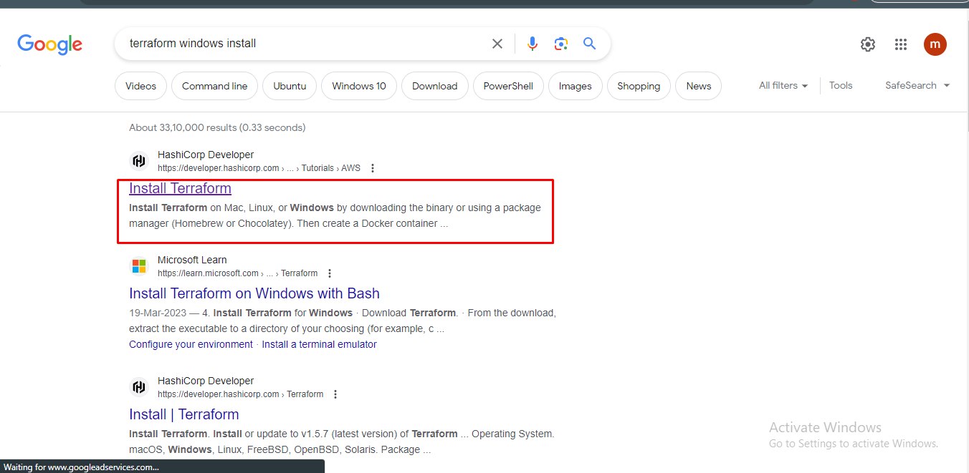

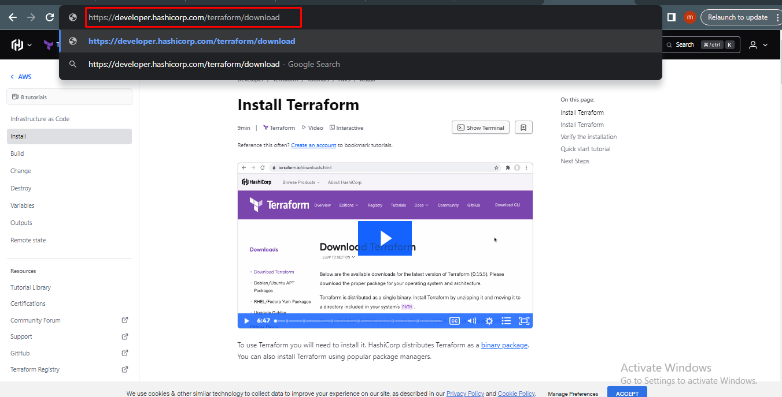

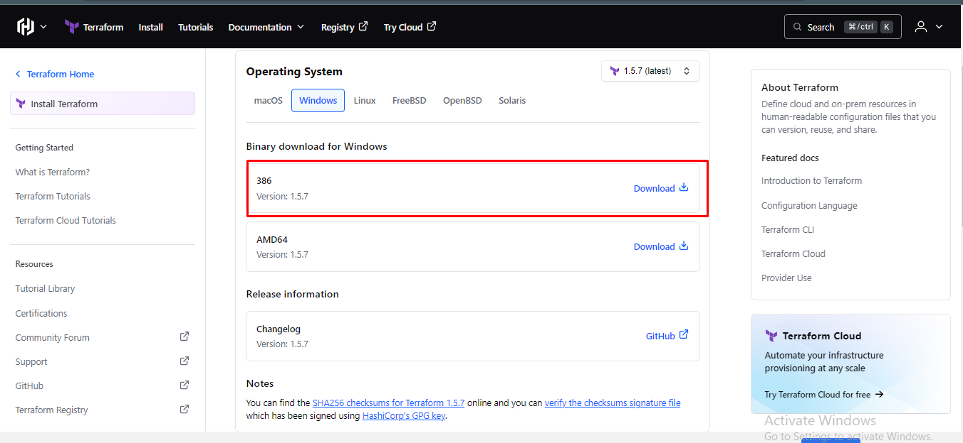

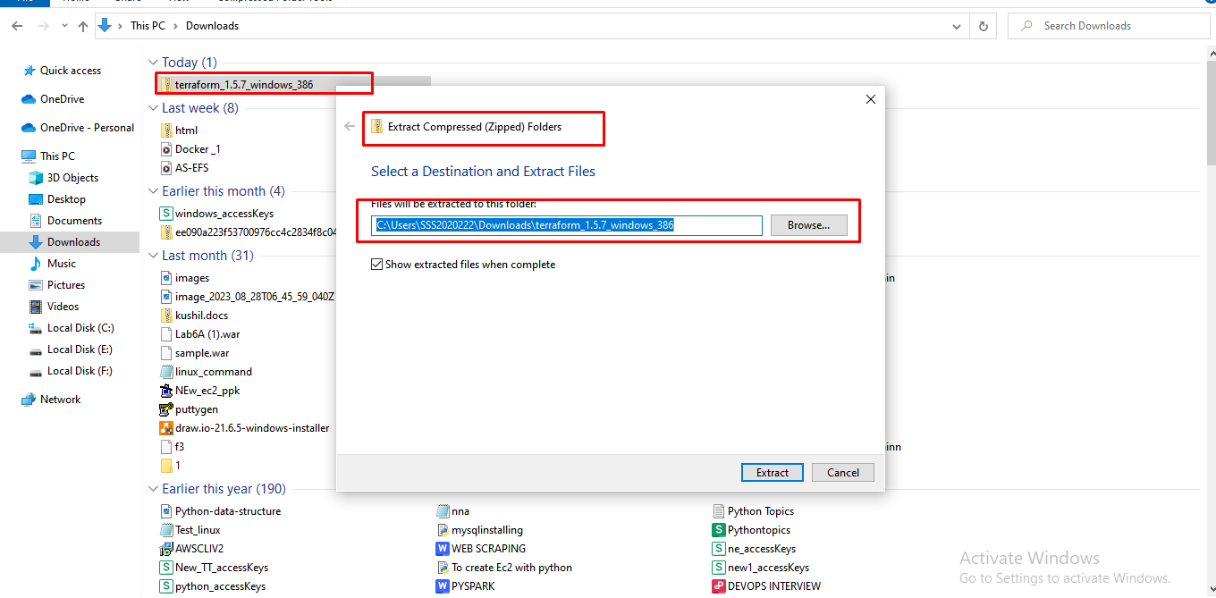

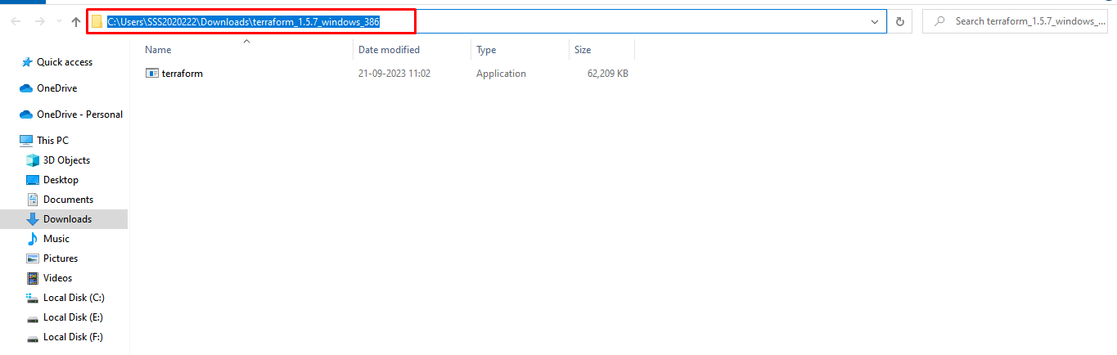

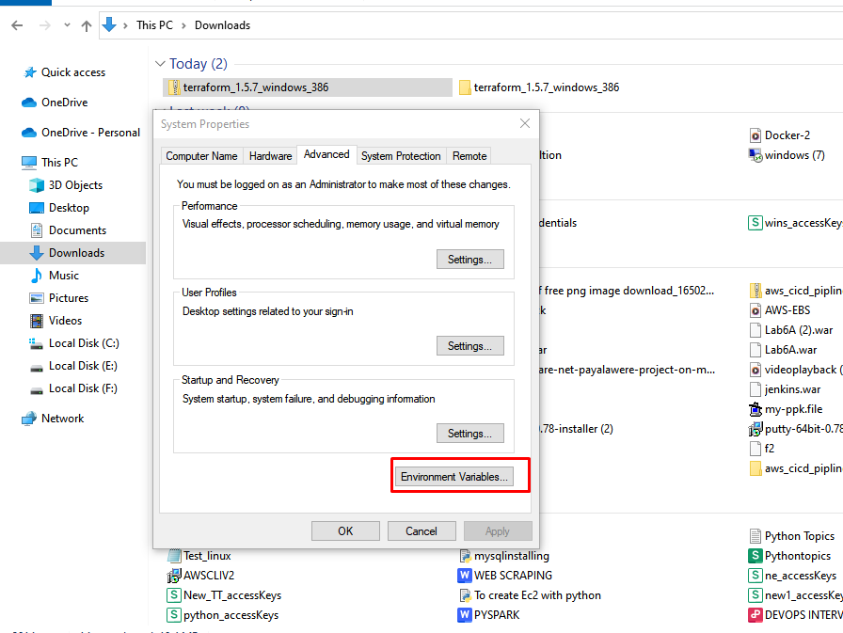

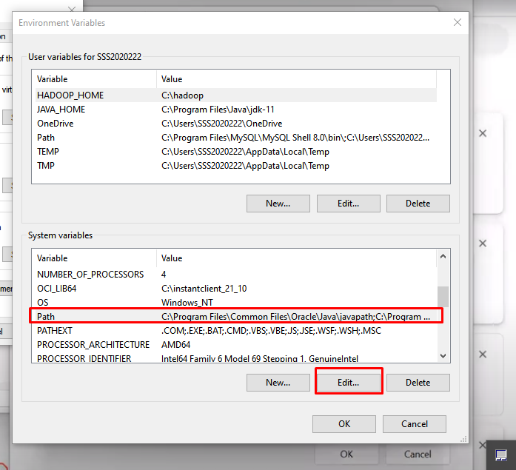

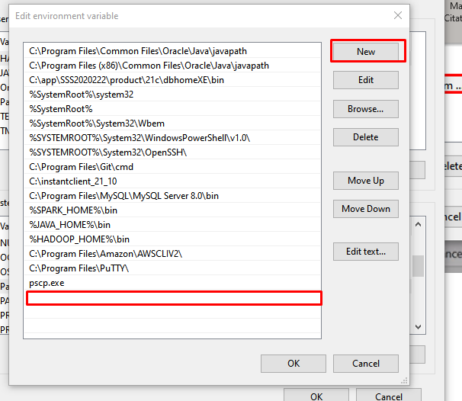

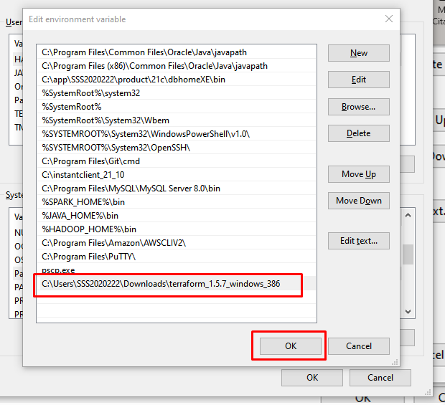

Now Goto Git bash or command run I Take git bash It install in a windwos server

